Dear All
This is a short newsletter to keep you in touch with our situation due to the current COVID19 restrictions, We aim to keep you up to date with everything we are doing to ensure we continue to provide information, advice and support through this time. Through the current COVID19 restrictions we have had to temporarily close Ashville Lodge again, however, we are much more prepared and able to offer you more services and facilities to keep in touch and get involved.
We aim to continue creating opportunities through connecting people to participate in community and working with us to support each other through this time. We have provided information about current support and activities together with details and guidelines to help you join in and keep in touch.
We will work with you to ensure everyone has access to our services and will support you in finding the best facility we can offer to make this support accessible. From the reopening of Ashville Lodge in September 2020, we have adapted and ensured the centre is, and will continue to be, a safe environment for you to return to as soon as we are able to open our doors again. You can contact us through our diversion facility that will take you through to our Advocacy Officer, he will direct you to the appropriate service,
Diversion number:
0151 651 0635 Alan Smith
As the Spring- time is around the corner, we look forward to a new year with renewed confidence and assurance that our charity will continue to grow with new skills and ability we have all built to come through some of the most difficult times. This can only work to strengthen and develop our services and support networks that have been further developed through the past 12 months.
Let us all work together with the positivity you have all shown; we are nearly there!
Take care everyone and stay positive.

Reflection
What is this life, so full of care?
We have no time to stand and stare.
Until now.

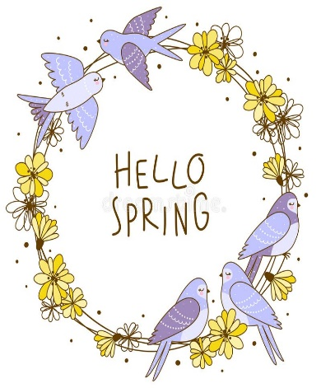
COVID19 has brought with it very dark times and uncertainties. However, nature sometimes forces us to look back, reflect and see things in a different way. Looking back over the years, we have been caught up in speed, being blinkered by the need to achieve everything with little time to look around us, caught up in the tyranny of technology, tethered to our phones and juggling to find a balance between the real and online world.
The world is an enormous place and Technology has shrunk it considerably and opened so many new opportunities, however, it cannot shrink the wonders of the real world, but it can increase our ability to link both.
So many people have started to turn to art and creativity; noticing birdsong, new life in the spring, colours of nature and the way we can express our feelings and emotions through art, music and poetry.
You may remember last year, we focused on posting feel good articles through art and music. One piece of work was a song called Through The Rain. it is from this we developed a new project to encourage people to explore their own creativity, look back at times that they remember and create their own work to reflect thoughts and feelings.
The next couple of pages will explain this new project, why we felt this important and how you can get involved.
We have named this project ‘Coming Through The Rain.’
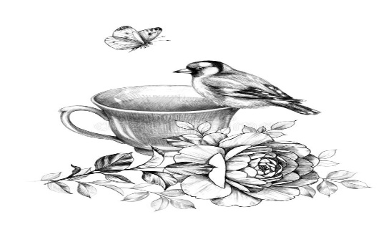

Coming Through The Rain Project
This project is funded by the P.H.Holt Foundation over a period of 12 months. The initial plan was to be run from Ashville Lodge Resource Centre as part of our return from the COVID restrictions. This has had to be reviewed due to the new restrictions being put in place and leading to the second closure of Ashville Lodge. The meeting was held to discuss the first six-week delivery during this lock down period.

It was agreed that the project could be delivered remotely using technology and meeting platforms. The main aim of this is to re-build confidence through using art and creativity capturing individual stories and experiences and applying them to create pieces of work reflecting these shared ideas

Taking a slightly different approach, the project will link with COVID19 through reflecting upon time of difficult challenges from past to present, this will link with history e.g., Wartime
We are very excited to be running this project and would like to encourage your input through ideas, memories and artwork. You can get involved in many ways and our team are here to support you in using methods of access such as WhatsApp, zoom, telephone and email. Where appropriate these methods will be complemented by video, phone, and postal support, particularly if you have difficulty getting online, so, do not worry, you can all join in.
For further information you can email Lynne on:
lynne@wirralsociety.org.uk
You can then be directed to one of our tutors, Jo Tudor, Keith Ryan and Clare Watson who will help you to access the facilities we have.
We look forward to your involvement and the development of this exciting new project.
If you have not already done so, you can access the music video this project is based on using
https://youtu.be/yaPSITxlbak (sunshine through the rain

More News
Bringing People Together

Although we are in a time where Social distancing is affecting everything we work for, this does not mean we are socially disconnected. Social connection is core to our mental wellbeing, and there are many ways we can stay connected, including virtually. We are now more prepared and able to keep people connected with each other through these difficult times.
Bringing People Together is top of our list. We are working to set up support and social networks that can be used to build support networks by telephone and social media platforms. We are currently running successful groups through WhatsApp and zoom where people can share experiences, common interests and generally keep in touch. Our team will be available to support you in accessing these groups. If you would like to get involved, you can contact Lynne on email: lynne@wirralsociety.org.uk or Alan on 0151 651 0635.
Stay connected, have fun, and stay safe.e

Counselling Support Service

Support Co unselling S

You are not alone

Sponsored by The Eye Fund

Counselling Supp
Providing a safe and confidential environment at Ashville Lodge working with individuals to explore emotions and feelings around diagnosis. Appointments are available and currently take place on a Tuesday and will also be available on a Wednesday morning on the re-opening of Ashville Lodge. Our Counsellor, Joy Hawitt is a member of the BACP (British Association of Counsellors & Psychotherapists). Enquires can be made via email: lynne@wirralsociety.org.uk
or by our current diversion facility
0151 651 0635

Ser I will be providing a safe and confidential environment at Ashville Lo

With Thanks

We would like to take this opportunity to thank all our members, friends and supporters for the help and support given over this time. We are extremely grateful to everyone for working with us to continue our services and prepare for a safe return to Ashville Lodge. We have already managed to do most of the work required to ensure a safe and compliant environment to return to and we reassure everyone we will continue to work and build upon our services. We look forward to welcoming everyone back to Ashville Lodge as soon as we are able. We will keep you in touch of progress.
With out thanks and very best wishes.

You a
Sponsored by The Eye Fund

c

ng Support Service

